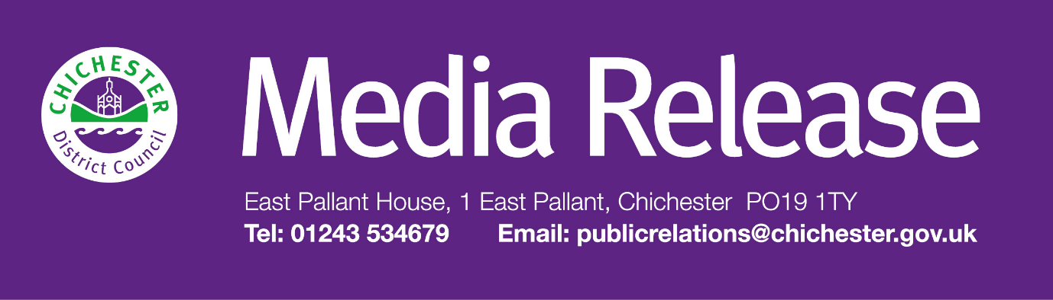

**Date of Release:** 3 September 2024                                                           **Ref:** 4359

**Green light given for programme of festive events in Chichester’s Priory Park**

A series of festive events will be brought to Chichester’s Priory Park in December after leading councillors gave the green light for funding.

At their meeting on Tuesday 3 September, Cabinet agreed to fund a nine-day programme of festive events and activities at The Guildhall in Priory Park and the park itself. This will coincide with a Christmas market which is being delivered by an external operator between 7 and 15 December, which the council is supporting.

The proposed festive offering includes arts and crafts activities, musical performances by local choirs and musicians, plus two silent discos. The council will also commission a short, bespoke pantomime which will be written and produced by two local actors. The finished work will then be performed in The Guildhall between 13 and 15 December.

“We were disappointed not to be able to deliver the ice rink because of the cost, but we were really determined to put together an alternative programme of events in order to help support the high street during the festive period and to give residents across the district and visitors something to look forward to in the city centre,” explains Councillor Adrian Moss, Leader of Chichester District Council. “As part of the project we’ll be working with the Culture Spark programme on some family-friendly arts and crafts activities, while The Novium Museum will be looking at some festive story telling. In addition, the silent discos are being organised to coincide with The Novium Museum’s forthcoming exhibition launching close to Christmas called ‘I Grew Up 80s’.

“We’ll also be dressing and lighting The Guildhall for the festive period, and we may also bring in a vintage fairground ride and an eco-friendly Christmas tree to link in with a tree trail being organised by the Chichester BID.

“Although not completely finalised yet, we hope that this festive programme offers something for everyone, including our younger residents, and complements other events being offered elsewhere in the city.”

Residents can find out more details about Christmas events and information by signing up to Chichester District Council’s email newsletter at [**www.chichester.gov.uk/newsalerts**](http://www.chichester.gov.uk/newsalerts)and by following the council on Facebook, X, Instagram and Nextdoor.

**ENDS**

**For further information, please contact Clare Hawkin, Senior Communications Officer at Chichester District Council on 01243 521298 or** [**chawkin@chichester.gov.uk**](mailto:chawkin@chichester.gov.uk)

________________________________________________________________________   
  
LEGAL DISCLAIMER   
  
This e-mail and any files transmitted with it are confidential and intended solely for the use of the individual or entity to whom they are addressed. However, any views or opinions presented are solely those of the author and do not necessarily represent those of Chichester District Council.   
  
If you are not the intended recipient or the person responsible for delivering the e-mail to the intended recipient, be advised that you have received this e-mail in error and that any use, dissemination, forwarding, printing or copying of this e-mail is strictly prohibited.   
  
Communications on or through Chichester District Council's computer systems may be monitored or recorded to secure effective system operation and for other lawful purposes.   
  
If you have received this e-mail in error please notify the Chichester District Council administrator.   
  
E-mail or phone 44 (0) 1243 785166   
  
[contact@chichester.gov.uk](mailto:contact@chichester.gov.uk)