news release
18 April 2024

Driving forward with multi-million-pound boosts for West Sussex bus travel

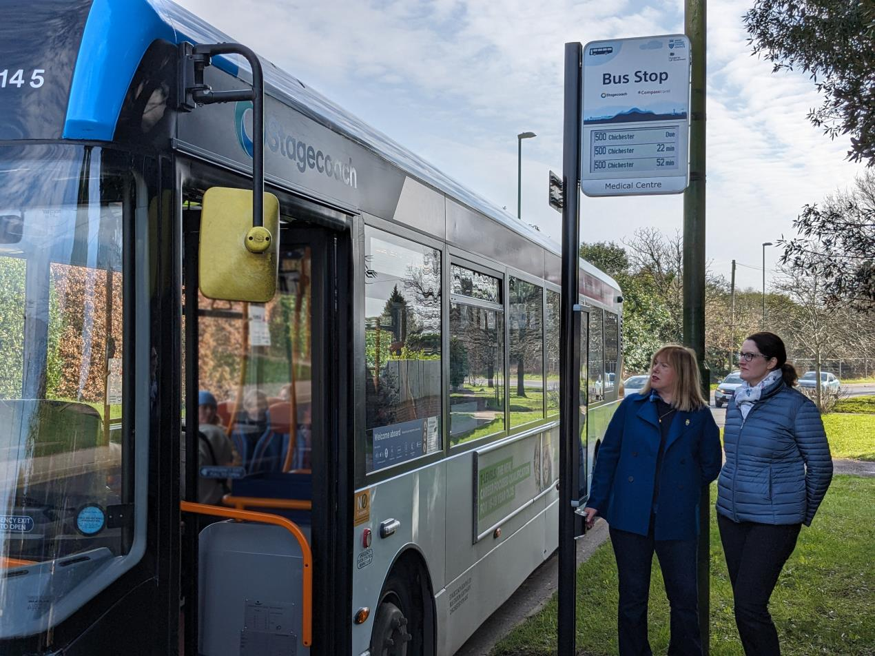
Pictured: Cllr Joy Dennis, Cabinet Member for Highways and Transport (left), with county council officer Liz Robbins, who is leading on the rollout of the new Real Time Passenger Information displays. They are pictured at a bus stop in Barnham Road, Eastergate. Cllr Dennis is testing the audio push-button facility, which will make bus travel easier for passengers with visual impairments, learning or reading difficulties.

Two new initiatives are underway to further improve bus travel in West Sussex. More than 400 Real Time Passenger Information (RTPI) digital displays are being installed countywide in a £3.3million programme and traffic lights are also being upgraded at 24 junctions to give buses priority in a £1.4million scheme.
The improvements are all part of West Sussex County Council’s, Department for Transport-funded Bus Service Improvement Plan (BSIP) in support of this more sustainable travel option.
The installation of the RTPI displays started in January and is progressing at a rate of around 16 per week. The traffic light junction upgrades started in November 2023 with 10 having been completed to date.
These junctions now have more dynamic control systems which respond to traffic movements in real time, giving priority to buses while minimising delays for other road users. They are concentrated on the Coastliner 700 bus route, which is one of the busiest in the country, and are in Southwick, Shoreham, Lancing, Worthing and Bognor Regis. There will also be upgrades in Crawley as part of the programme.
Cllr Joy Dennis, the county council’s Cabinet Member for Highways and Transport, said: “Developing a modern infrastructure is a key part of our Council Plan and by providing improvements for bus travel we are supporting sustainable travel options, which are an important aspect of the West Sussex Transport Plan 2022 – 2036.
“I’m particularly pleased to see the county-wide spread of the new Real Time Passenger Information displays. Their locations include bus stops near vital community facilities, such as hospitals and doctors’ surgeries, and in rural areas where bus services are a lifeline and so important in helping to reduce feelings of isolation.
“If you live in a town, there could be a bus service running every 20 minutes or so, but if you’re in a rural area and the service is hourly, you really want to know it’s on its way, or if it has been delayed. These displays will help residents feel confident that using the bus will get them where they want to be, on time.”
The 'Real-time' displays show the bus service number, its destination and departure time. All feature a special audio push-button facility to make bus travel easier for passengers with visual impairments, learning or reading difficulties.
You can see a map of the completed and future RTPI installation on our website, where there is also a list of the traffic light junction upgrade locations.
Further details of bus services and offers can be found on our “Bus-It” pages.
Roads Minister Guy Opperman said: “Local people deserve a modern, reliable, and affordable public transport system. I'm delighted to have worked alongside West Sussex County Council and local MPs to give the council over £19million to boost its bus services.
“Installing new digital displays at bus stops will make it easier to plan journeys while improving traffic lights will make buses more punctual and reliable, helping residents get around by bus more easily and with greater peace of mind.”
Notes to editors
Following the launch of the Bus Back Better bus strategy for England in March 2021, the county council and local bus operators committed to form an Enhanced Partnership (EP) to deliver an improved bus offer in West Sussex, and to contribute to the ambitions set out in the West Sussex Transport Plan and the Climate Change Strategy.
The partnership developed the Bus Service Improvement Plan (BSIP) outlining ambitions to dramatically improve bus services in West Sussex, to reverse the Covid-related shift in journeys away from public transport and encourage passengers back to bus through greater local leadership.
Following submission of the BSIP in October 2021, the DfT has awarded West Sussex County Council a total of £19million to boost bus services.
​

For further information please contact the news desk on 0330 222 8090 or email pressoffice@westsussex.gov.uk.
For urgent out-of-hours enquiries please call 07767 098415.

