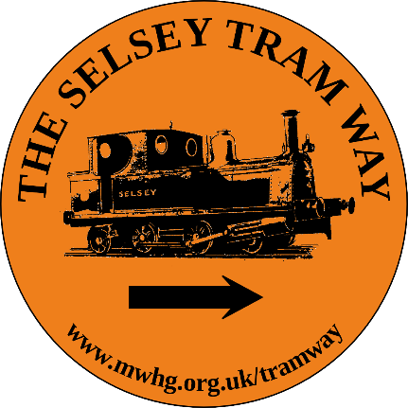

The Selsey Tram Way

Bulletin No 20
(December 2023)

Seasons Greetings

Headline News
Novium Exhibition
Walk The Selsey Tram Way
Chalder Station Update

Tramway Exhibition at The Novium
The exhibition on The Selsey Tramway will be staged at The Novium from June 2024 until March 2026 with a launch date of Friday 28th June.
The exhibition will comprise a wall vinyl, a powerpoint presentation of photograpohs, a range of artefacts and a film. The wall vinyl will display a timeline of the Tramway and a description of what can be seen today, a map of the route with information about the stations, an explanation of the overall Tramway Project and the role of the Manhood Wildlife & Heritage Group. The film will contain archive footage of the Tramway, interviews with former employees, a description of a journey, the Selsey Shanymen singing the Sidlesham Snail and drone footage of part of the heritage trail. A ‘Walks & Talks’ proramme will be arranged to support the exhibition
Walk The Selsey Tram Way
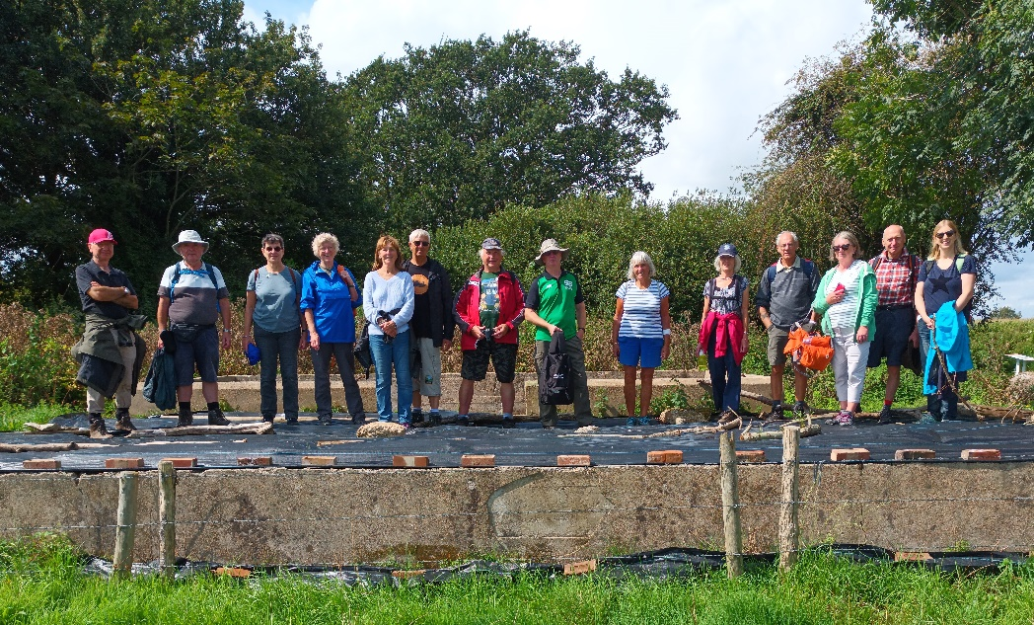
On 26th August 25 people met at East Beach car park in Selsey to walk to Sidlesham passing the sites of 8 of the tramway stations. Despite persistent rain for the first half of the walk 15 of us made it to Chalder Station.

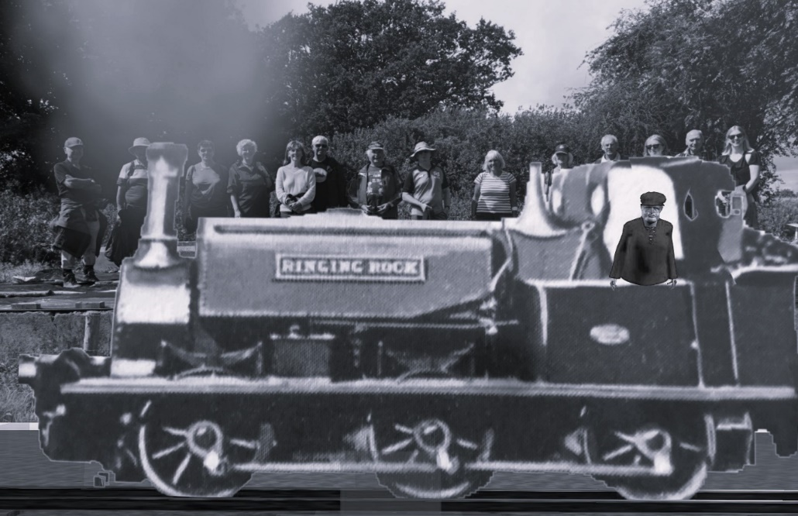
We were even rewarded with a surprise visit from ‘Ringing Rock,’ one of the Tramway’s original locomotives!

Photo: David Haynes

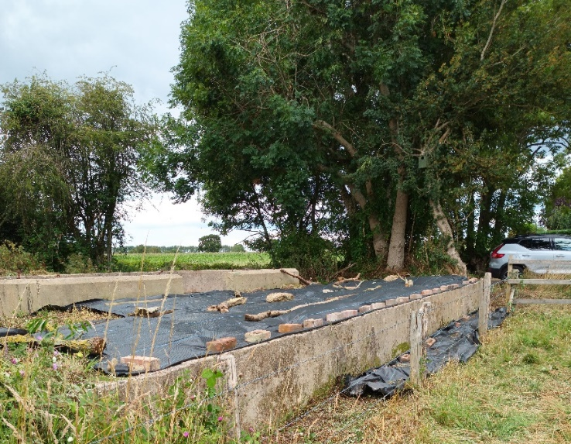
Update on Chalder Station
In July a volunteer work party cleared vegetation and put down weed control matting in prepoaration for the walk in August. There will be another work party in the Spring – details in the new year.
We have also met with a representative of Trackwork, a company providing infrastructure to the UK rail network to discuss the possibility of re-instating track alongside the platform – watch this space.

Seasons greetings to you all and thanks for your continued interest & support.

Contact: Bill Martin billm89@hotmail.com 07931 363 573
David Pearce dmp@metronet.co.uk

Spiby Partners Seley Town Council Govia ThameslInk
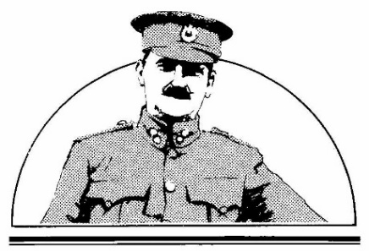

Lady Neville Foundation
Colonel Stephens Society

